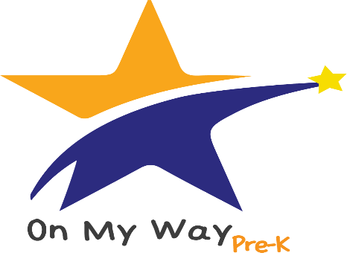

READY FOR SCHOOL.
PREPARED FOR SUCCESS.

See if your child can get FREE PRE-KINDERGARTEN at El Campito Child Development Center.
If you check every box, APPLY NOW ONLINE OR AT BRIGHTPOINT.
Will your child be 4 years old by August 1st ?
Do you qualify for low income assistance?
Are all parents/guardians in the household working or attending an accredited/certified education or
training program?
Do you want your child to be ready for kindergarten?
Do you want FREE pre-kindergarten education for your child?

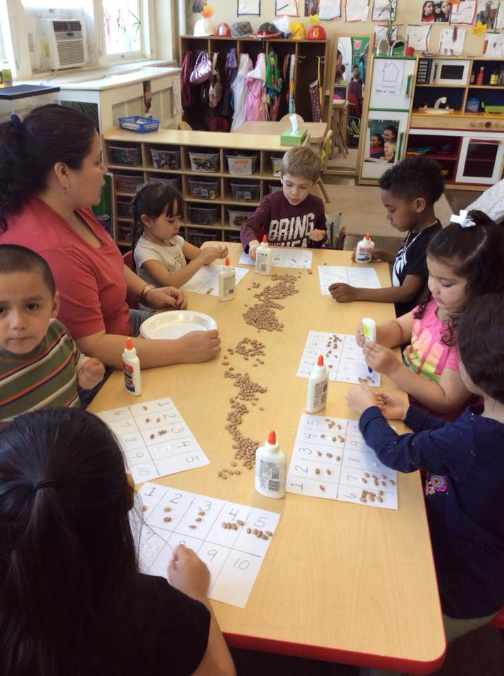

TO APPLY, GO TO WWW.ONMYWAYPREK.ORG
OR CALL 800-299-1627

